**DAILY ONLINE ACTIVITIES SUMMARY**

|  |  |  |  |  |  |  |  |  |
| --- | --- | --- | --- | --- | --- | --- | --- | --- |
| **Date:** | 30-06-2020 | | | | | **Name:** | Anvitha H M | |
| **Sem & Sec** | 4th ‘A’ | | | | | **USN:** | 4AL18CS010 | |
| **Online Test Summary** | | | | | | | | |
| **Subject** | | N/A | | | | | | |
| **Max. Marks** | | 30 | | **Score** | | | - | |
| **Certification Course Summary** | | | | | | | | |
| **Course** | Statistical methods for decision making. | | | | | | | |
| **Certificate Provider** | | | Great learning academy | | **Duration** | | | 7.5 hours |
| **Coding Challenges** | | | | | | | | |
| **Problem Statement:** C++ program to move all the zeroes to the end of array using pointers. | | | | | | | | |
| **Status:** Executed | | | | | | | | |
| **Uploaded the report in Github** | | | | | YES | | | |
| **If yes Repository name** | | | | | <https://github.com/alvas-education-foundation/Anvitha-H-M> | | | |
| **Uploaded the report in slack** | | | | | Yes | | | |

**Online test:**

N/A

**Certification course:**

Statistical methods for decision making.

The course includes detailed explanation on basics of probability, marginal probability and Bayes theorem.

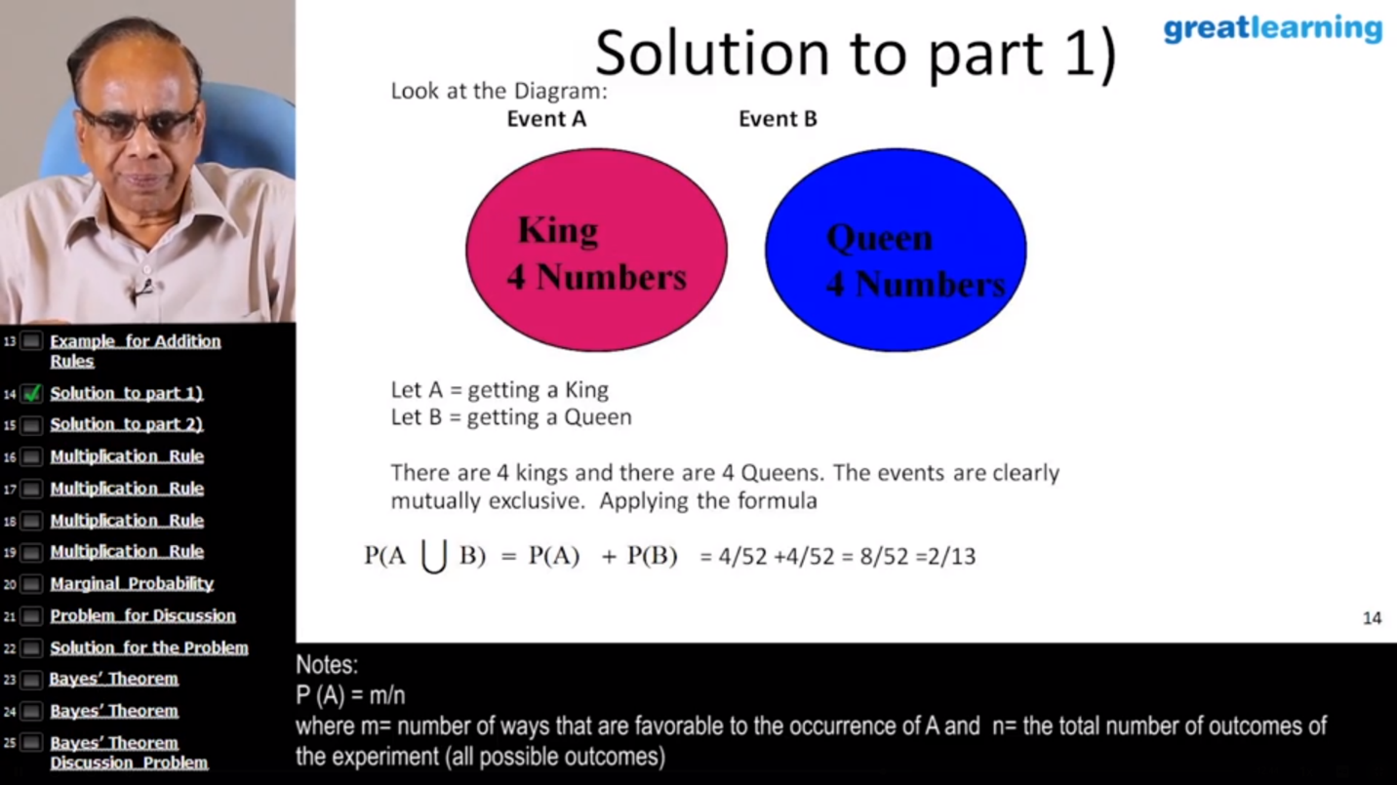

Online coding challenge

The programing statement of the day is

“C++ program to move all the zeroes to the end of array using pointers.”

Solution: Executed and uploaded in Github repository.

Link: <https://github.com/alvas-education-foundation/Anvitha-H-M>

